AI Use Declaration Form
Course: Introduction to Artificial Intelligence
Lab Title: Lab 1A
Student Name: Caleb Winner Koufie
Student ID:31042028
GitHub Repository Link: https://github.com/CALEB-KOUFIE/Caleb_Koufie_Lab1.git
Date Submitted: 20/06/2026

1. AI Use Summary
Question | Student Response
Did you use any AI tool for this lab? | YES
Estimated percentage of work influenced by AI | 15%
Did you attach evidence of AI use where applicable? | YES

2. Details of AI Use
Complete the table below for each AI tool used. Add more rows where necessary.
Name of AI Tool Used | Purpose for Using the Tool | Prompt or Instruction Given to the Tool | Part(s) of the Work Influenced by the Tool | How I Verified, Edited, or Improved the AI Output
ChatGPT | Understanding | I think I do not really understand the while loops, so eleborate on those for me, in the functions, specifically the (while node is not None, while node is not None and node.parent is not None:, etc..) | The reverse | Rewrote the code using my understanding
ChatGPT | Understanding | These are the functions before the first todo, I do not understand why the moves are so so explain it carefully for me | Grid problem

3. Attachment of AI Output Evidence
Where required, attach evidence of AI use. Tick all that apply. Add more rows where necessary.
Evidence Type | Attached? (Yes, No, N/A) | File Name
AI-generated draft
Prompt history
Screenshot of AI interaction | yes
Exported AI conversation
AI-generated code snippet
Revised version showing student input

4. Student Declaration
I declare that:
Declaration Statement | Response (Yes/No)
The submitted work is my own work. | Yes
Any use of AI tools has been clearly declared in this form. | Yes
The prompts, instructions, and AI-generated outputs have been disclosed where applicable. | Yes
I reviewed, tested, edited, and improved any AI-generated content before submission. | Yes
My AI usage does not exceed 25% of the entire work. | Yes
I understand that undeclared or excessive AI use may be treated as academic misconduct. | Yes

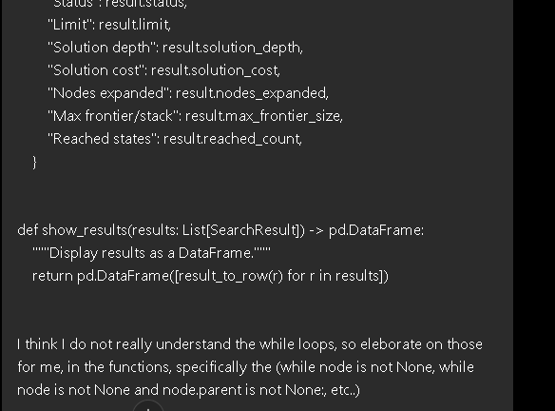

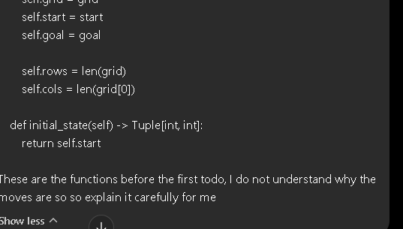

Student Signature: Caleb Winner Koufie
Date: 20/06/2026

